Please open a fresh Excel worksheet to explore accessing multiple tables simultaneously via a single folder.

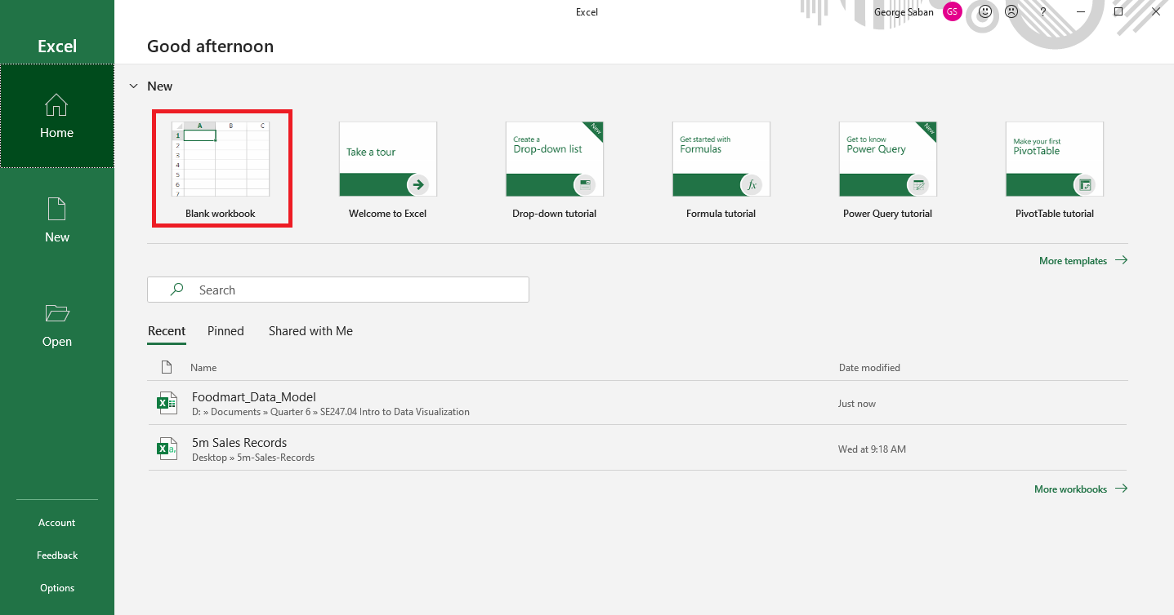

Open an instance of file explorer and navigate to the location in memory where the FoodMart folder is stored. Afterwards, create a new folder labeled “Transactions”.

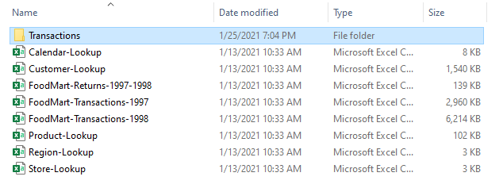

Select the “FoodMart_Transactions_1997” and “FoodMart_Transactions_1998” files and transfer them directly into the Transactions folder. This process allows power query to point to the contents of the folder instead of a single file. The new folder’s contents should be akin to the image below.

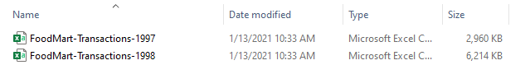

In Excel, navigate through the following: Data tab 🡪 Get Data 🡪 From File 🡪 From Folder

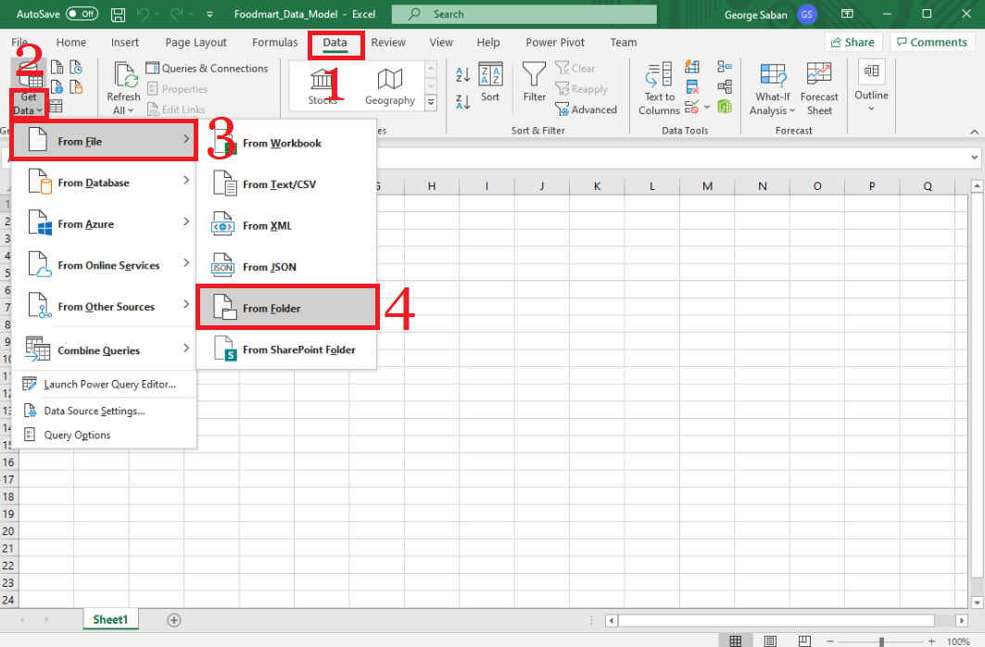

Afterwards, browse through and select the Transactions folder created earlier. Then, press “OK”.

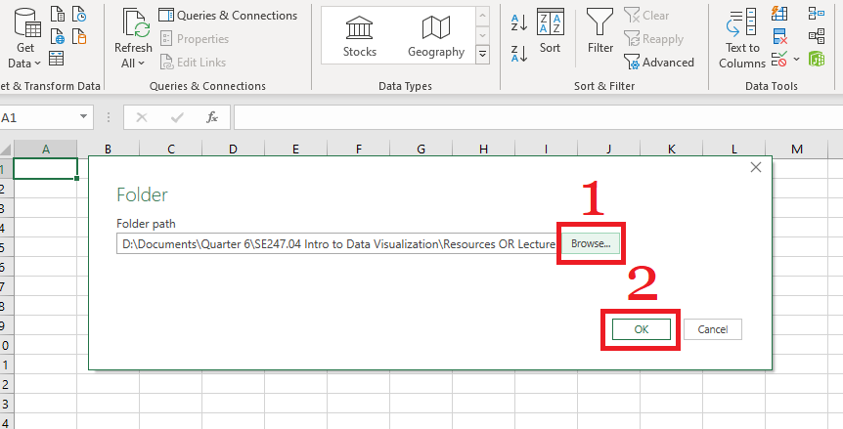

In the new pop-up window, select the “Transform Data” button.

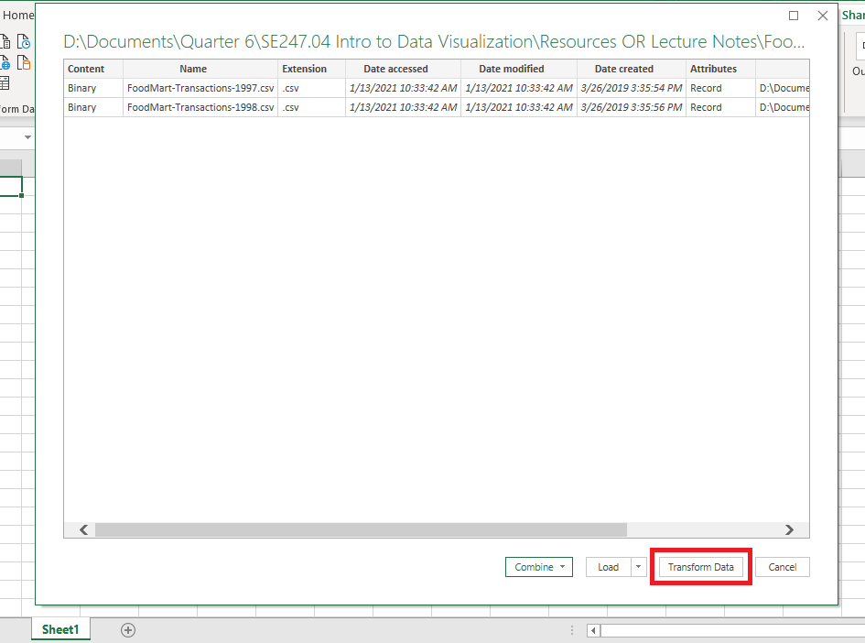

Note: The arrow button shown in the image below is a useful feature to view current queries loaded into your Excel data model. To close the interface, select the arrow again.

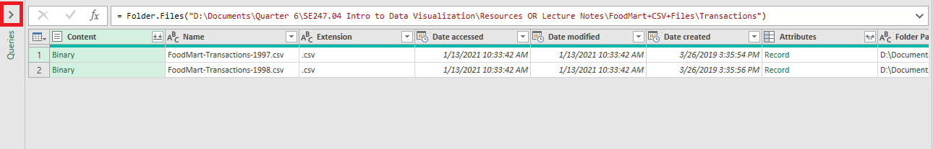

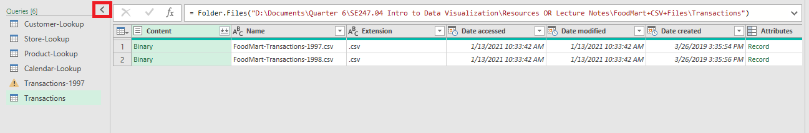

To combine the contents of the folders, select the double downwards arrow button located on the right-hand side of the Content attribute header.

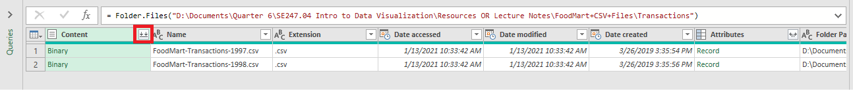

In the pop-up window, the setting parameters should remain the same (refer to the image below). Select “OK” to continue.

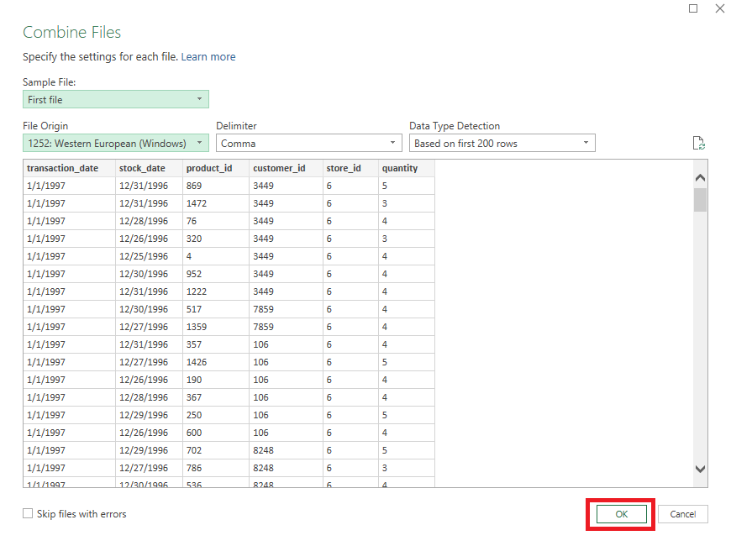

Notice that the temporary table in the power query editor contains FoodMart Transactions from both years (1997 & 1998). This can be confirmed by temporarily changing the sorting order of the “transaction_date” field from ascending to descending.

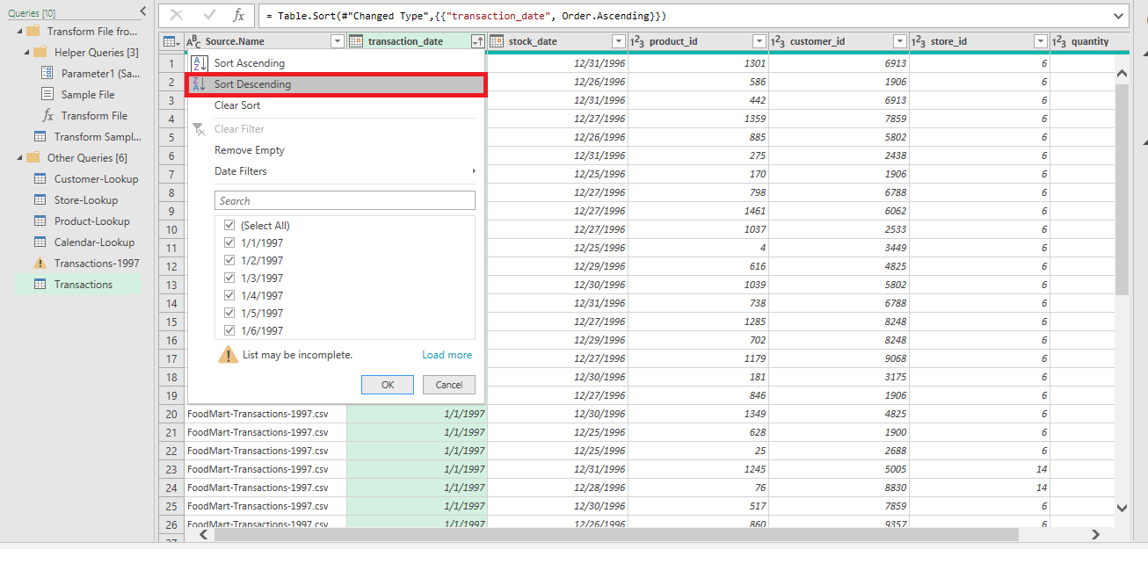

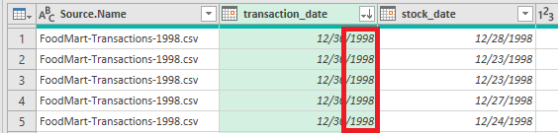

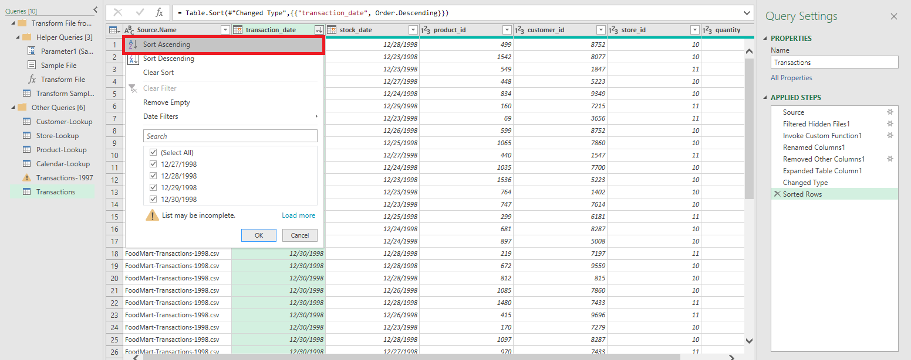

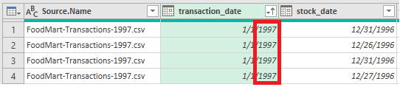

In this demonstration, the transaction_date field values have matching year values with the Source.Name attribute’s year values. Since the Source.Name field is a duplicate field, please remove the field by right-clicking 🡪 remove.

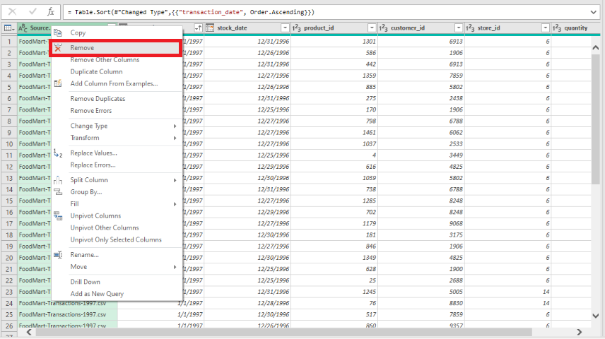

To load the table into the data model, please follow the following navigation: under the Home tab, select Close & Load To 🡪 Only Create Connection 🡪 Add this data to the Data Model 🡪 OK (refer to the images below for assistance).

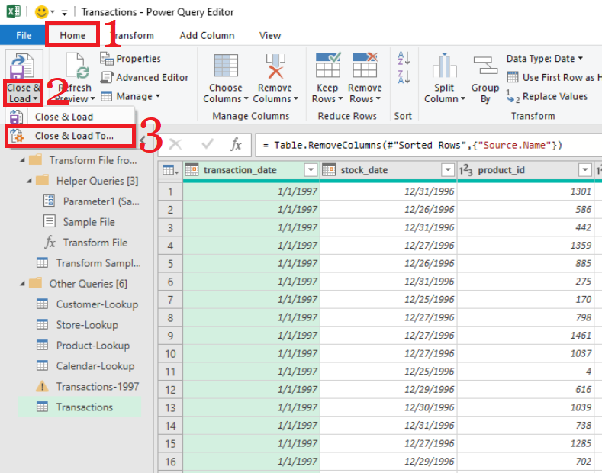

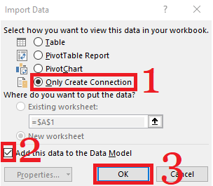

In the “Queries & Connections” right-hand side panel, collapse the “Transform File from Transactions” folder.

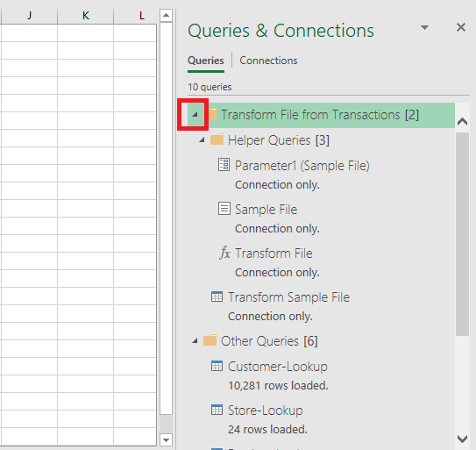

At this point, the Transaction table should be loaded into the data model with 269,720 records.

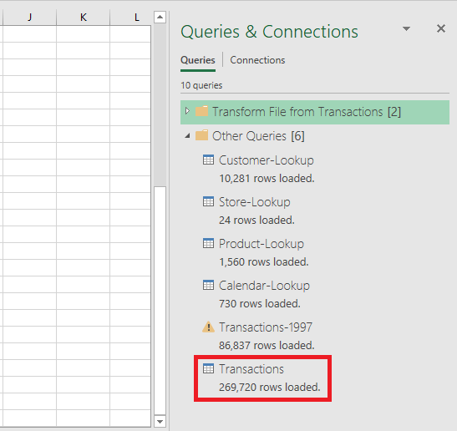

To confirm the successful entry of data, navigate to the Data tab and select the “Power Pivot Window” under the Data Tools section.

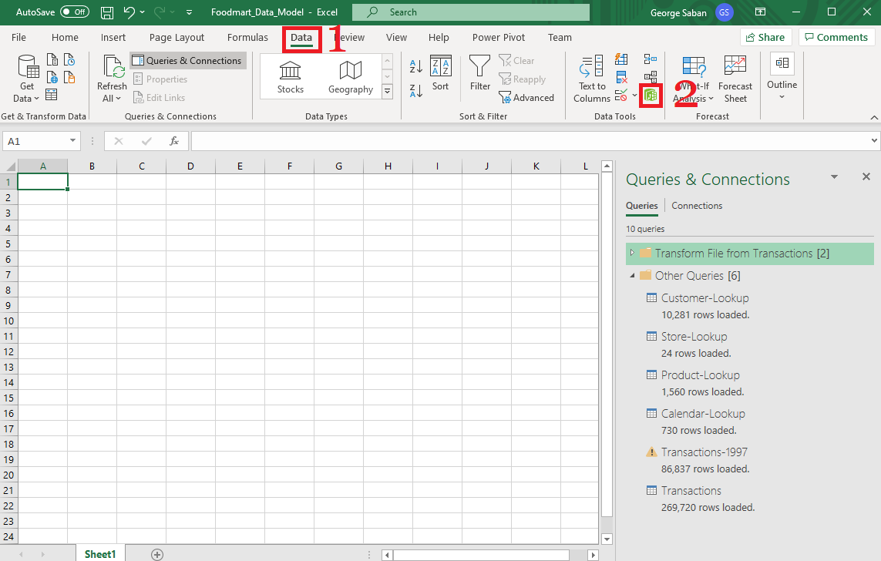

The Transaction table should look like the one shown below.

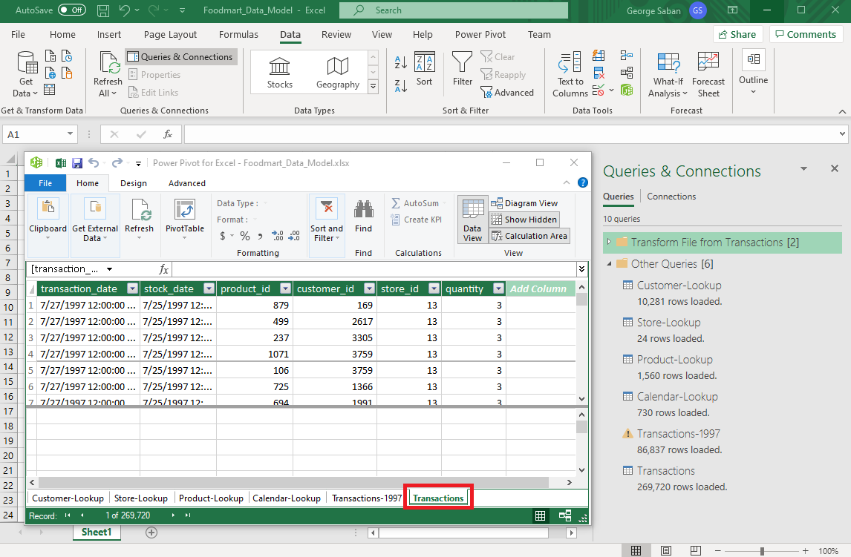

Before submitting to Canvas, please ensure that you have saved your work.

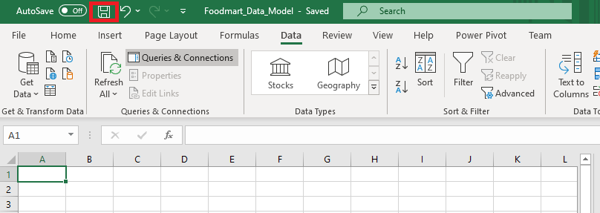

**Your Turn!**

By now, you have practiced several times importing an external file. Using the same technique, Load the **Region_Lookup** csv file from the raw resources folder into your data model, and use the **Query Editor**to confirm that region_id is formatted as a whole number and all other columns are formatted as text.

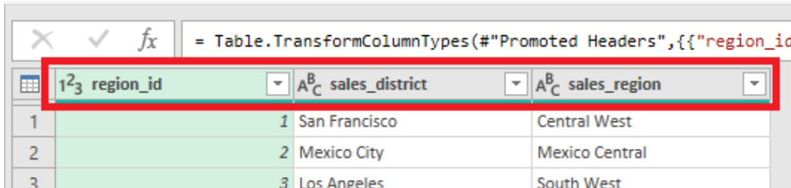

To submit to canvas:

1. Resize Excel and take a snapshot using Window's Snipping Tool.
2. Please ensure that the system's date, your name, and the Transactions & Region-Lookup tables are included in the image (please refer to the example below).
3. Submit to Canvas in PNG format.

